5. Write a program using Arduino to control LED

1. One or more ON/OFF
2. Blinking

a.One or more ON/OFF

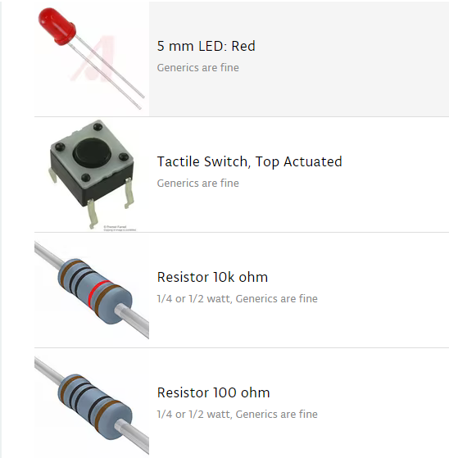



**Block Diagram**

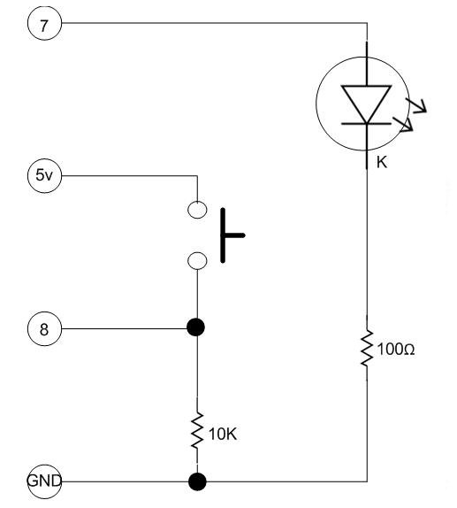

**Code**

**#include <stdio.h>**

**#include <stdlib.h>**

**const int button = 8; // GPIO 8 for the button**

**const int led =7; // GPIO 7 for the LED**

**int ledflag=0; // LED status flag**

**void setup() {**

**pinMode(button,INPUT); // define button as an input**

**pinMode(led,OUTPUT); // define LED as an output**

**digitalWrite(led,LOW); // turn output off just in case**

**}**

**void loop() {**

**if (digitalRead(button)==HIGH){ // if button is pressed**

**if (ledflag==0) { // and the status flag is LOW**

**ledflag=1; // make status flag HIGH**

**digitalWrite(led,HIGH); // and turn on the LED**

**} //**

**else { // otherwise...**

**ledflag=0; // make status flag LOW**

**digitalWrite(led,LOW); // and turn off the LED**

**}**

**delay(1000); // wait a sec for the**

**} // hardware to stabilize**

**} // begin again**